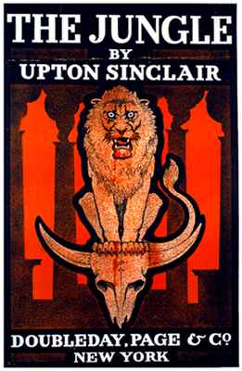
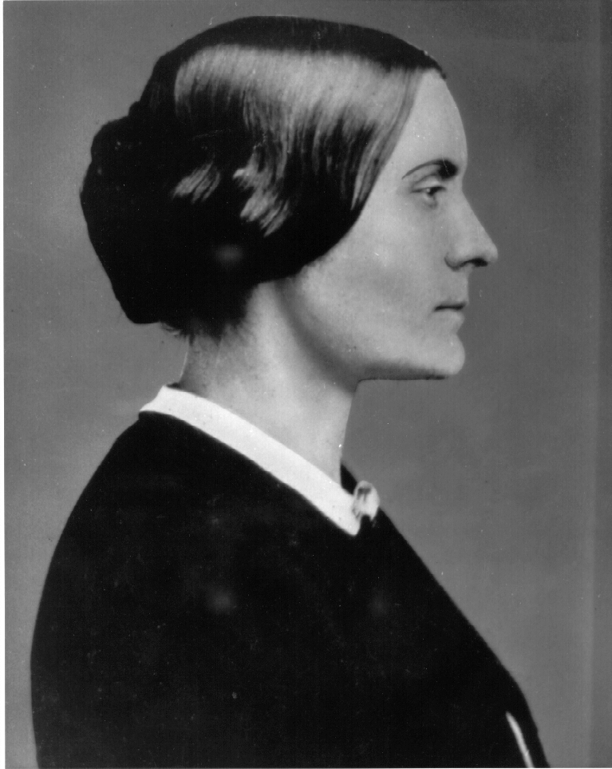
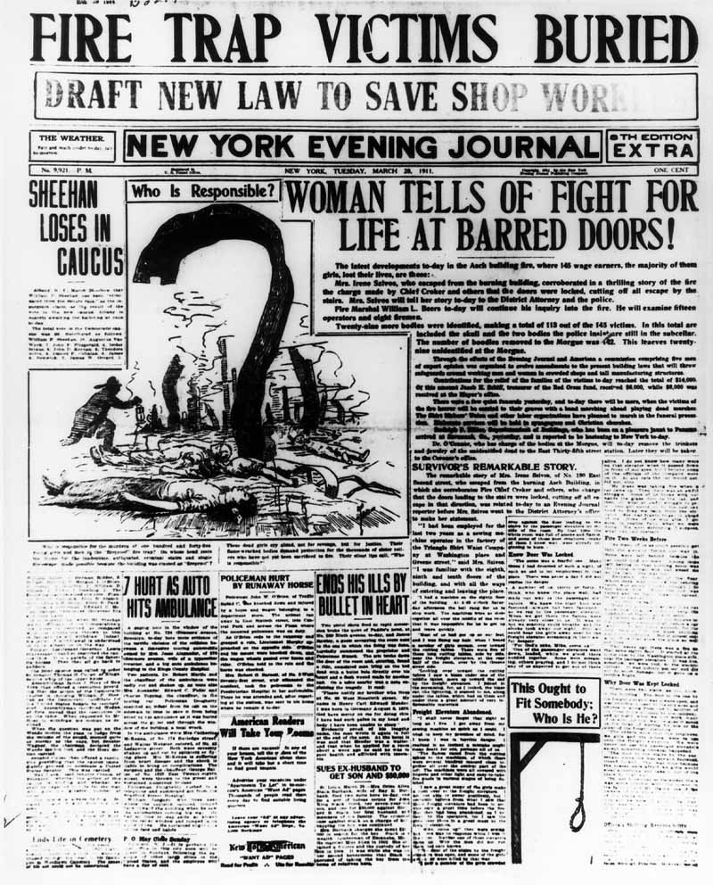
The People who put the PROGRESS in the Progressive Era

Directions: Today, you will have the opportunity to uncover the voices of the people who put the “progress” in the Progressive Era. These people fought for causes before they were popular and stood up for what they believed was wrong with society. As you read their words, analyze each document, discuss with your group and respond to the questions below!
“The Triangle Shirtwaist Company Fire Claims 146 Lives” (1911) (5 points)
- What conditions seemed most responsible for the high loss of life? How might they have been remedied?

- How much of the public outrage about the fire owed to the fact that so many of the dead were young women?

- Imagine that you were President Taft during the Triangle Shirtwaist Company Fire. What laws would you pass to guarantee that a tragedy like this never happened again?

“The Status of Woman” by Susan B. Anthony (1897) (5 points)
- According to Anthony, how has the women’s rights movement progressed since the Seneca Falls Convention in 1849?

- What does Anthony believe needs to happen before we see the “highest development of the race”?

“Give Mother the Vote” and “Women’s Place is in the Home” (1915) (5 points)
Give Mother the Vote Woman’s Place is in the Home
Describe what you see in the cartoon: Describe what you see in the cartoon:

What is the main argument of the cartoon? What is the main argument of the cartoon?

Which do you think proved most persuasive that women deserve greater rights in society? EXPLAIN.

“Exposing the Meat Packers” (1906) (5 points)
- Make a list of the most appalling aspects of the meat packing industry.

- Which aspects of the meat packing conditions were most detrimental to public health?

- Based on this excerpt, why do you think Sinclair entitled his work, The Jungle?

